**Detailed CLP Template**

*(Please refer to pages 24 – 33 of the CLP guidance)*

|  |  |
| --- | --- |
| Development Name: |  |
| Landowner: |  |
| Site address: |  |
| Site postcode: |  |

|  |  |
| --- | --- |
| Construction Logistics Manager: |  |
| Phone number: |  |
| Email: |  |
| Logistics provider contact name: |  |
| Phone number: |  |
| Email: |  |

|  |  |  |
| --- | --- | --- |
| CLP Produced by: | | |
| Name | Signature | Date |
|  |  |  |
| CLP Accreditation date: | |  |
| CLP Reviewed by: | | |
| Name | Signature | Date |
|  |  |  |
| CLP Accreditation Date: | |  |

|  |  |
| --- | --- |
| Site contact details (in hours): |  |
| Site contact details (out of hours): |  |

**1 INTRODUCTION**

* 1. CLP Objectives

*This section should set out the objectives of the CLP, such as reduced vehicles or lower associated emissions, and site-specific objectives.*

* 1. Site Context

*Description of the site location outlining local authorities, nearby highway and transport links and any relevant contextual information. Hours of operation, Traffic Management Orders that may be required, events.*

* 1. Development Proposal

*Outline a proposed demolition and build, including unit numbers and size.*

* 1. CLP Structure

*Table of contents and figures.*

**2 CONTEXT, CONSIDERATIONS AND CHALLENGES**

2.1 Policy Context

*Outline any relevant policies, such as The Traffic Management Plan (2004), the Draft London Plan (2019), any relevant local policy.*

2.2 Three plans at different scales (1 A3 Page each)

*To include the following plans:*

* *Regional plan* *with a scale smaller than 1:15,000) showing:*
  + *The location of the work site(s) in the context of main roads, cycle routes, water ways, railways and other key infrastructure*
  + *Freight delivery infrastructure.*
* *Local context plan with a scale of between 1:2,000 and 1:3,000) showing:*
  + *The location of the site in the context of surrounding roads, footways, cycle routes and other infrastructure*
  + *Potential marshalling areas*
  + *Community considerations.*
* *Site boundary plan with a scale of between 1:500 and 1:1,000 showing:*
  + *The local context of the area with a fine level of detail (OS data) as currently provisioned highlighting the extent of footways, other buildings, cycle lanes and road markings.*

2.3 Local access including Highway, Public Transport, Cycling and Walking

2.3.1. Highways, Carriageways and Footways

*Describe any adjacent highways, carriageways and footways or nearby roadways requiring extra*

*attention, such as red routes. Include proposed TRO’s required during at any stage of construction.*

2.3.2. Railway/ Underground

*Describe nearby running lines and any necessary precautions to prevent disruption.*

2.3.3. Bus routes

*Describe nearby bus routes and any necessary precautions to prevent disruption.*

2.3.4. Cycling

*Describe nearby cycle routes or hubs and any necessary precautions to prevent disruption.*

2.4 Considerations and challenges

*2.4.1. Community considerations detail any nearby notable building uses that require special attention and propose mitigation strategies. Example: Schools. Hospitals, places of worship, community centres, retail areas etc.*

**3** **CONSTRUCTION PROGRAMME AND METHODOLOGY**

*The charts in this section are to be made using the construction logistics planning tool on the CLP website. The following are example outputs from the spreadsheet. Provide a high-level description of the construction programme and include tables generated through the linked tool.*

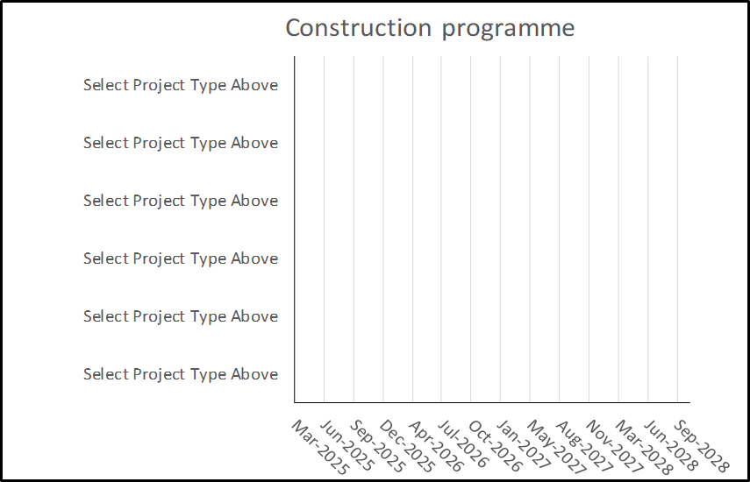



3.1.1. SITE SETUP AND DEMOLITION

*Outline setup and demolition phase, including timings, plant and vehicles required and works description.*

3.1.2. BASEMENT EXCAVATION AND PILING

*Outline basement excavation and piling phase, including timings, plant and vehicles required and works description.*

3.1.3. SUB-STRUCTURE

*Outline sub-structure phase, including timings, plant and vehicles required and works description.*

3.1.4. SUPER-STRUCTURE

*Outline super-structure phase, including timings, plant and vehicles required and works description.*

3.1.5. CLADDING

*Outline cladding phase, including timings, plant and vehicles required and works description.*

3.1.6. FIT-OUT, TESTING AND COMMISSIONING

*Outline fit-out, testing and commissioning phase, including timings, plant and vehicles required and works description*

**4 VEHICLE ROUTING AND ACCESS**

*To include the following plans, which are marked up versions of the plans placed earlier in the CLP:* *(A3 maximum size)*

* *Regional plan:* (*with a scale smaller than 1:15,000)*
  + *Strategic roads that are likely to be used to access the site.*
* *Local plan:* (*with a scale of between 1:2,000 and 1:3,000)*
  + *Local area routing including turn back routes*
  + *Local access roads may be required to be used for the last stages of a journey to site.*
  + *Specific access routes on the local roads should be identified. The connection to/from*
  + *local roads to the strategic road network should also be shown*
  + *Consolidation centres and vehicle holding centres.*

***Lower*** *and* ***Medium*** *impact sites require a single plan at this scale showing the typical site layout.*

***High*** *impact sites require multiple plans at this scale showing the site layout during the different phases of construction.*

* *Site plan:* (*with a scale of between 1:500 and 1:1,000)*
  + *Local access to the site:*
  + *Hoarding lines with access gates (vehicle, pedestrian and cyclist)*
  + *Pedestrian and cycle access and routes both into and on site*
  + *Loading areas*
  + *Lorry marshalling areas*
  + *Vehicle routing on site (including swept paths on site vehicle movements)*
  + *Crane location(s)*
  + *Potential areas of conflict*
  + *Parking (vehicle and cycle), loading and unloading arrangements*

**5 STRATEGIES TO REDUCE IMPACTS**

[Delete Medium/High Impact Planned Measures Checklist as required]

|  |  |  |  |
| --- | --- | --- | --- |
| Medium Impact Planned Measures Checklist | Committed | Proposed | Considered |
| Measures influencing construction vehicles and deliveries | | | |
| Safety and environmental standards and programmes | X |  |  |
| Adherence to designated routes | X |  |  |
| Delivery scheduling | X |  |  |
| Re-timing for out of peak deliveries  Re-timing for out of hours deliveries | X |  |  |
| Use of holding area and vehicle call off areas |  | X |  |
| Use of logistics and consolidation centres |  | X |  |
| Vehicle choice |  | x |  |
| Measures to encourage sustainable freight | | | |
| Freight by Water* |  |  | X |
| Freight by Rail* |  |  | X |
| Material procurement measures | | | |
| DfMA and off-site manufacture |  |  | X |
| Re-use of material on site |  | X |  |
| Smart procurement |  | X |  |
| Other measures | | | |
| Collaboration with other sites in the area |  |  | X |
| Implement a staff travel plan | X |  |  |

*If site, consolidation centre or holding areas are within 100m of foreshore of navigable water-way or rail freight siding.

|  |  |  |  |
| --- | --- | --- | --- |
| Higher Impact Planned Measures Checklist | Committed | Proposed | Considered |
| Measures influencing construction vehicles and deliveries | | | |
| Safety and environmental standards and programmes | X |  |  |
| Adherence to designated routes | X |  |  |
| Delivery scheduling | X |  |  |
| Re-timing for out of peak deliveries  Re-timing for out of hours deliveries | X |  |  |
| Use of holding area and vehicle call off areas |  | X |  |
| Use of logistics and consolidation centres |  | X |  |
| Vehicle choice |  | X |  |
| Measures to encourage sustainable freight | | | |
| Freight by Water* |  | X |  |
| Freight by Rail* |  | X |  |
| Material procurement measures | | | |
| DfMA and off-site manufacture |  | X |  |
| Re-use of material on site |  | X |  |
| Smart procurement |  | X |  |
| Other measures | | | |
| Collaboration with other sites in the area | X |  |  |
| Implement a staff travel plan | X |  |  |

*If site, consolidation centre or holding areas are within 100m of foreshore of navigable water-way or rail freight siding.

5.1.1. Measures influencing construction vehicles and deliveries

*(Describe the measures mentioned in the checklist)*

*Safety and environmental standards and programmes*

***Outline measures that will be undertaken to adhere to FORS, CLOCS and other standards and***

***programmes.***

*Adherence to designated routes*

***Outline measures that will be undertaken to ensure vehicles arriving at the site location will adhere***

***to routes designated in Section 4.***

*Delivery scheduling*

***Outline the system that will be implemented to ensure deliveries to site are scheduled and recorded.***

*Re-timing for out of peak deliveries*

***Outline proposals for how deliveries will be re-timed out of peak hours.***

*Re-timing for out of hours deliveries*

***Outline proposals for how deliveries will be re-timed out of hours.***

*Use of holding and vehicle call off areas*

***Outline a proposed strategy for use of a holding and vehicle call off area.***

*Use of logistics and consolidation centres*

***Outline proposals for the use of load consolidation and a consolidation centre for both contractors***

***and sub-contractors.***

5.1.2. Measures to encourage sustainable transport

*Freight by Water (if site, consolidation centre or holding areas are within 100m of foreshore of navigable waterway)*

***Outline the feasibility of delivering to site by water.***

*Freight by Rail*

***Outline the feasibility of delivering to site by rail.***

5.1.3. Material procurement measures

*DfMA and off-site manufacture*

***Outline proposals for the use of pre-fabrication and off-site manufacturing of construction material.***

*Re-use of material on site*

***Outline proposals for re-using material on site.***

*Smart procurement*

***Identify suppliers who have been recognised to implement measures in line with the CLP’s objectives, such as reducing vehicle movements.***

5.1.4. Other measures

*Collaboration amongst other sites in the area*

***Outline proposed opportunities to collaborate with neighbouring construction sites, such as sharing***

*holding areas.*

*Implement a staff travel plan*

***Outline the staff travel plan for staff and workers travelling to site.***

**6 ESTIMATED VEHICLE MOVEMENTS**

The charts in this section are to be made using the construction logistics planning tool contained in the CLP Guidance. These can be found at - <https://constructionlogistics.org.uk/construction-logistics-and-planning/>

Estimated construction vehicles – monthly and daily



Estimated construction vehicles – monthly and daily

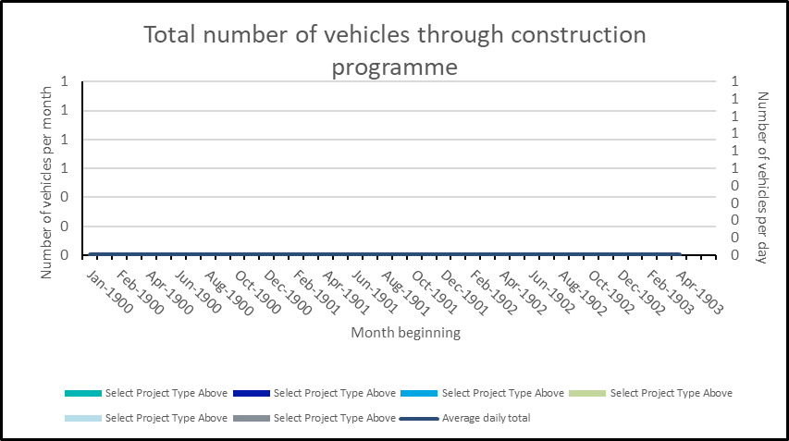

Number and vehicle type by phase of construction

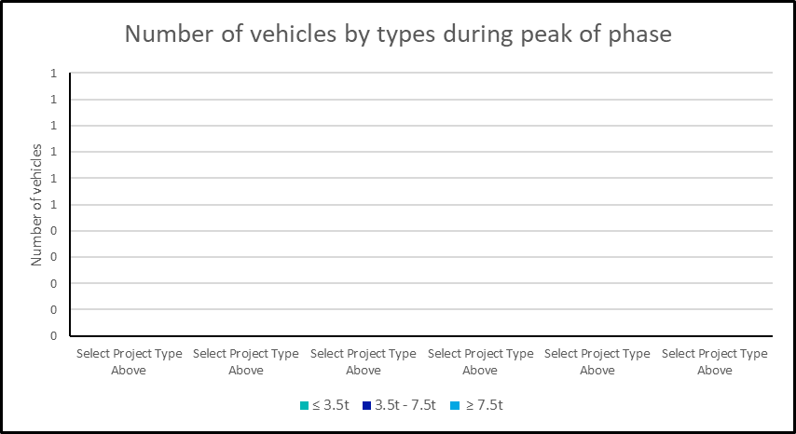

Hourly arrival profile of vehicle during peak

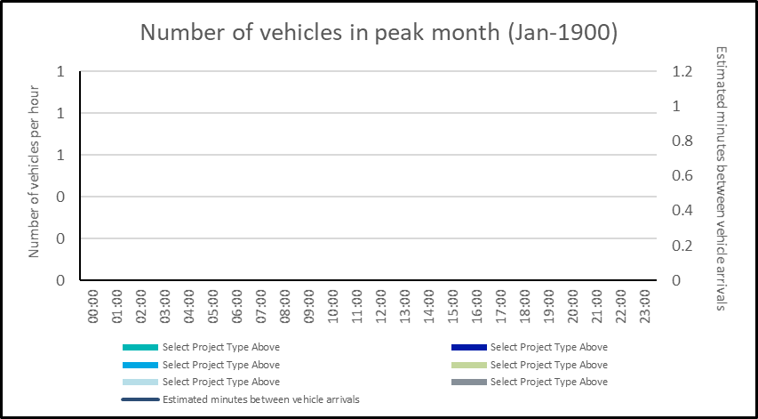

**7 IMPLEMENTING, MONITORING AND UPDATING**

*Describe a proposed system for implementing the Outline CLP on site, and how this will be monitored regularly and updated. The Detailed CLP will require a far more detailed description, once a contractor has been appointed.*