Property and Asset Management

Waltham Forest Town Hall, Forest Road, London E17 4JF

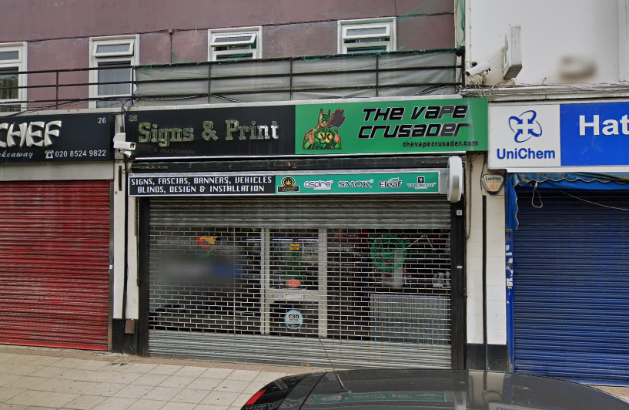

TO LET | LOCK-UP SHOP
 | 28 HATCH LANE
 | CHINGFORD E4 6LQ
LOCATION: | Access to the M11 and the North Circular Road.  British Rail nearby (Chingford Station).
DESCRIPTION: | Lock-up shop, reasonable condition with store / kitchen room and WC / shower, rear access. Large shed to rear. Parking available. Available immediately.
FLOOR AREA: | Net internal area approximately 859sqft (80 sqm). External storage 257sqft (24sqm)
TERMS: | Minimum lease of 3 years for Planning Use Class E.  Catering (hot food) subject to planning requirements
RENT: | Offers in the region of £13,000 pa (exclusive)
RATES: | 01 April 2023: Rateable Value £14,250  Subject to small business rates relief – please make own enquiries with Council Business Rates Team
COSTS: | All legal costs will be borne by the new tenant (Costs TBC)
VIEWING: | By prior appointment with Property Services (Sunil Kumar)
 | Telephone 020 8496 8069 / 07989 195 279 or email: sunil.kumar@walthamforest.gov.uk
OFFERS: | To Sunil Kumar, Area Estate Manager.
 | Include:
- Details of your proposed use and length of lease required.
- Proof of identity i.e. a copy of passport / driving licence and a recent utility invoice for home address (no more than 3 months old)
- Last six months bank statements, together with mortgagees or landlords reference, two trade referees if applicable. 2-3 years trading accounts.
These particulars do not form part of any offer or contract. All statements contained in these particulars are made without responsibility of the vendor/agent/lessor and should not be relied upon as statements or representations of fact. Any intending purchasers/tenants must satisfy themselves by inspection or otherwise as to the correctness of each of the statements contained in these particulars. The vendor/agent/lessor does not give any warranty whatsoever in relation to the property.



