London Borough of Waltham Forest
Chingford Mount Cemetery-Brochure
Fees and Charges from the 1st of February 2024
Chingford Mount Cemetery
Contents

Plots Suitable for Coffin and Ashes Burials
- Traditional Burial Plot
- Lawn Burial Plot

Plots Suitable for Ashes Burials Only
- Cremated Remains Garden Plot
- Half Grave Plots for Cremated Remains

Miscellaneous
- Memorial Benches
- Grave Search Fees
- Other Fees and Charges (Memorials and Grave Transfers)

Chingford Mount Cemetery
Traditional Burial
Traditional Headstone and full-length kerbing. Can accommodate two coffins and between four to six interments of ashes.
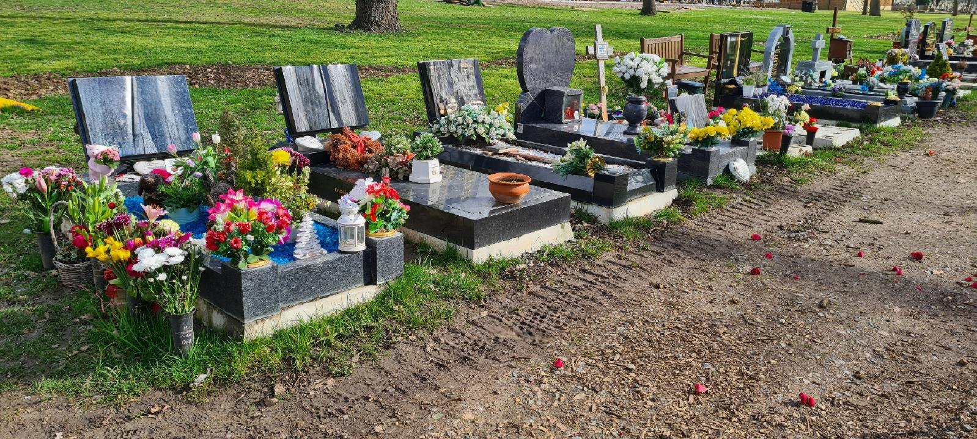

These plots are located next to one of our roadways and include a landing foundation which is ready to accept a full-length granite or marble memorial and surround (example above) to be fitted by your Memorial Mason. Please note that temporary wooden surrounds are not permitted as this prevents us from topping up the grave in preparation and readiness for the foundation and memorial.

Exclusive right of burial (50-year term) £3320

Interment Fee (one person) £1650

Landing foundation £755

Prime position fee £525

TOTAL (one person) = £6250

Extension of Burial Rights is £375 for a further 10 years.

(Traditional Memorial Permit Fee of £310 payable when installed by an approved Memorial Mason).

Chingford Mount Cemetery
Lawn Burial
Lawn Headstone and 18” Granite or Marble kerb-set. Can accommodate two coffins and between four and six interments of ashes.

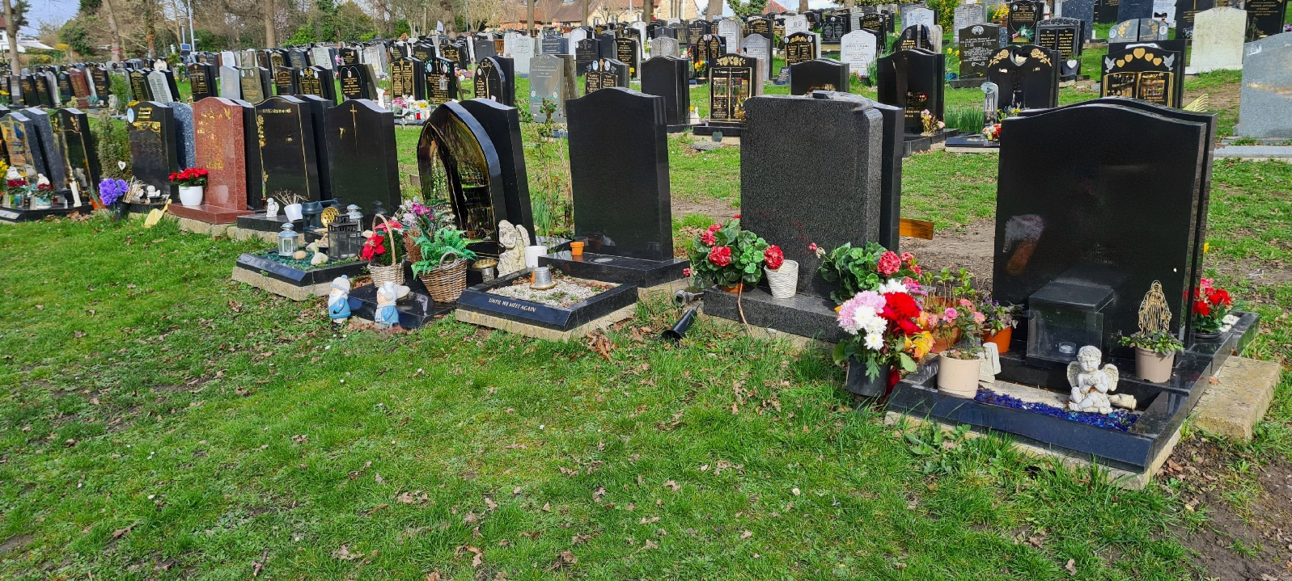

These plots include a headstone foundation which is ready to accept a granite or marble memorial (examples above). Only approved Memorial Masons may install Headstones and Kerb-sets which must have received a permit issued by the Cemetery Office.

Exclusive right of burial (50-year term) £2125

Interment Fee (one person) £1650

Headstone foundation £220

TOTAL (one person) = £3995

Extension of Burial Rights is £375 for a further 10 years.

(Lawn Headstone Memorial Permit Fee of £215 payable before installation).

Chingford Mount Cemetery
Cremated Remains Plot

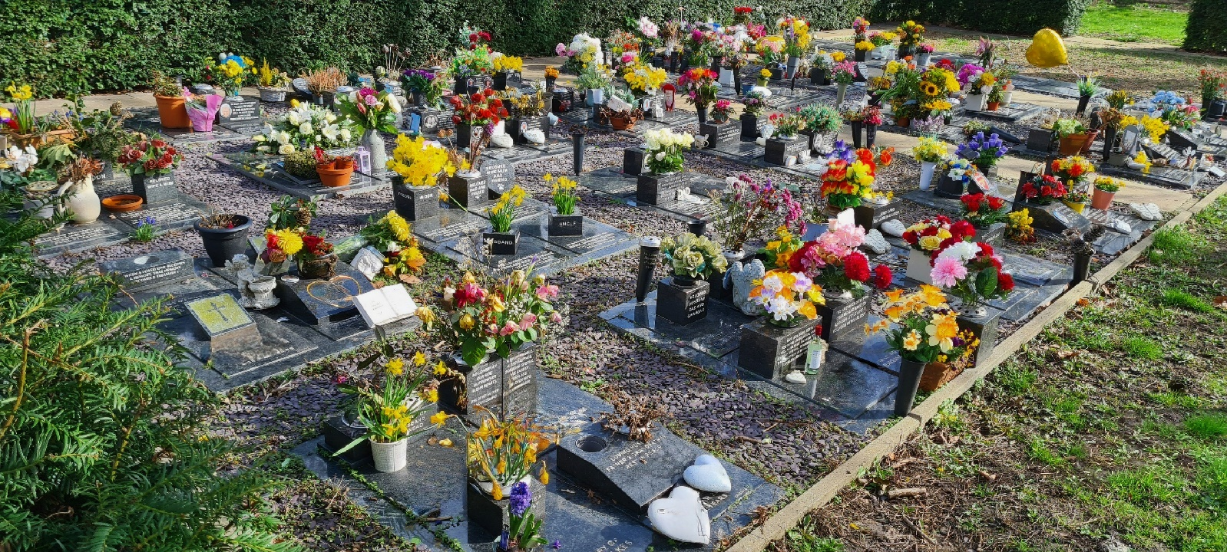

These plots are located in the Remembrance Garden, and allow for the interment of up to two sets of ashes. A granite tablet and inscription are included.

Exclusive right of burial (25-year term) £1245

Interment Fee (one person) £385

Interment fee (two persons) £770

Granite memorial tablet with first inscription £725

Second inscription on granite memorial tablet £285

TOTAL (one person) = £2355 TOTAL (two persons) = £3025

n.b. CRGA plots are strictly for the pouring of ashes only. Caskets, containers and other items are not permitted.
Extension of Burial Rights is £375 for a further 10 years.

Chingford Mount Cemetery
Half Grave for Cremated Remains Burial
Lawn Headstone permitted only – No Kerb-sets allowed. Can accommodate between four to eight interments of ashes.

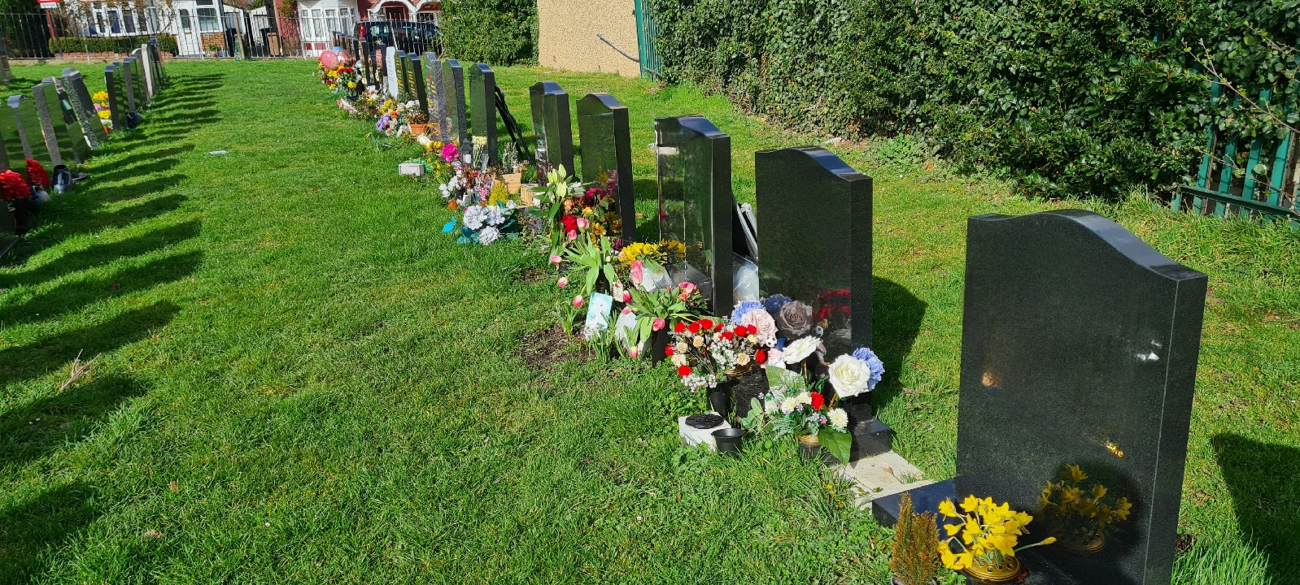

These plots include a headstone foundation which is ready to accept a granite or marble memorial (examples above). Only approved Memorial Masons may install Headstones which must have received permit issued by the Cemetery Office.

Exclusive right of burial (50-year term) £2125

Interment Fee (one person) £385

Headstone foundation £220

TOTAL (one person) = £2730

Extension of Burial Rights is £375 for a further 10 years.

(Lawn Headstone Memorial Permit Fee of £215 payable before installation).

Chingford Mount Cemetery
Memorial Bench

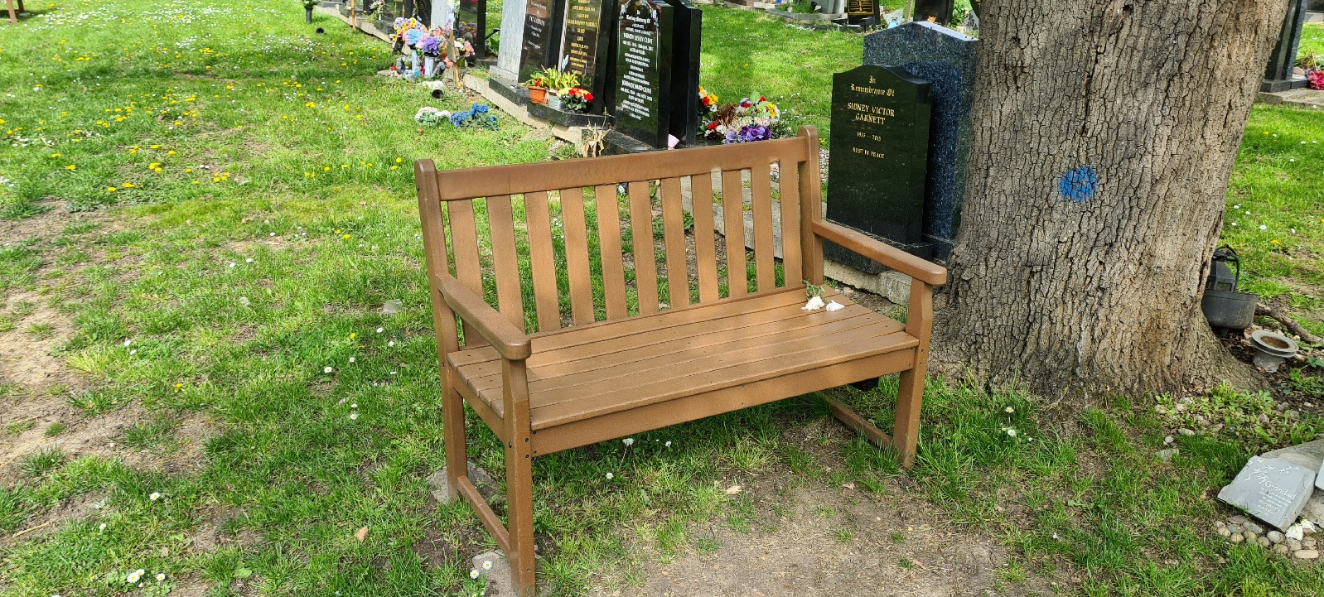

Polywood Bench 4’ (2-seater) - Price excludes dedication lettering £720.00
Bench Permit of 20 years for any bench installed in the Cemetery £410.00 Base for Bench £100.00
TOTAL £1230.00

Traditional Teak colour - Height x Width x Depth 35” x 48” x 24”

Carved dedication per letter £6.70

(Dedication wording must be 100% correct at time of ordering as mistakes cannot be rectified after carving is complete).

Only authorised benches with a signed permit will be allowed in the Cemetery.

* Please note that delivery from the manufacturer can be up to 16 weeks

Chingford Mount Cemetery
Search Fees

Grave Search Charges

£20.00 | Where a search is conducted via the cemetery office computerised records from 1978 onwards | Per name
£29.00 | Where the exact date of death is known pre-1978 | Per name
£55.00 | Where the date of death is within a given period of time | Per name / per 5-year search period
ADDITIONAL CHARGES WILL APPLY FOR:
£26.00 | For the provision of a photocopy of the burial record and a map showing the position of the grave within the boundaries of the Cemetery
£40.00 | For the provision of two photographs (per Grave) inclusive of postage or email
£30.00 | Accompanied visit to graveside (pre-booked)

A grave search request form must be completed by the applicant and sent with the correct payment to Chingford Mount Cemetery Office. We will endeavour to provide responses to family history searches within 28 working days of receipt of the request. Searches connected to a request for a burial will be prioritised and processed much more quickly.

Chingford Mount Cemetery
Miscellaneous

Removal & Replacement of Memorials (for burials)
Removal & replacement of headstone only {up to 36” high. Others price on application} |  | £160.00
Removal & replacement of traditional memorial |  | £320.00
Removal & Replacement of lawn kerb |  | £105.00
Removal & Replacement of larger memorials | Price on application
Re-opening of vault | Price on application
Erection of Memorials – {New Lawn graves not to exceed 36” in height,Traditional graves 39” and Chambers/Vaults 48”}
Headstone foundation |  | £220.00
Lawn headstone permit with one inscription only |  | £215.00
Additional inscription permit |  | £125.00
Wooden Cross permit when used as a Permanent Memorial |  | £225.00
Kerb-set permit |  | £120.00
Additional plate/plaque/book permit |  | £120.00
Vase permit |  | £120.00
Traditional memorial permit fee |  | £310.00
Levelling Memorials
Headstone & foundation |  | £145.00
Kerb set |  | £90.00
Certificates
Certificate of Exclusive Right of Burial |  | £97.00
Transfer of Exclusive Right of Burial |  | £87.00
Replacement Copy of Certificate of Exclusive Right of Burial – (Grave Deed) |  | £10.00

