London Borough of Waltham Forest

Additional Licensing Scheme Designation

Designation and map of area covered by proposed selective licensing designation

DESIGNATION OF AN AREA FOR ADDITIONAL LICENSING
Section 56, Housing Act 2004

The London Borough of Waltham Forest (“the Authority”) in exercise of its powers under section 56 of the Housing Act 2004 (“the Act”) hereby designates for additional licensing the area described in paragraph 4.

CITATION, COMMENCEMENT AND DURATION

- This designation may be cited as the London Borough of Waltham Forest Designation for an Area for Additional Licensing.
- The Designation is made on 9th July 2024 and shall come into force on 1st April 2025.
- It shall cease to have effect on 31st March 2030 (not more than five years) or earlier if the Authority revokes the scheme under section 84 of the Act.

AREA TO WHICH THE DESIGNATION APPLIES

- This designation shall apply to the area of the London Borough of Waltham Forest as delineated and edged red on the map annex A below.

APPLICATION OF THE DESIGNATION

- The designation applies to all Houses in Multiple Occupation (“HMOs’’) that:
(i) Meet the conditions in Section 254(2) of the Act (“the standard test”);
(ii) Meets the conditions in Section 254(3) of the Act (“the self-contained flat test”);
(iii) Meets the conditions in Section 254 (4) of the Act (“the converted building test”); or
(iv) An HMO declaration is in force in respect of it under section 255
as defined in annex B within the area described in paragraph 4 unless:

- the house is an HMO that falls within the nationally prescribed category of HMO that is required to be licensed as a ‘mandatory HMO’ under section 55(2)(a) Part 2 of the Act ;

- the house is subject to an Interim or Final Management Order under Part 4 of the Act;

- the house is subject to a temporary exemption under section 62 of the Act; or

- The house is an HMO that is a building or part of a building that is not an HMO for the purposes of licensing under Part 2 of the Act as defined in annex C.

EFFECT OF THE DESIGNATION

- Subject to sub paragraphs 5(a) to (d) above, every HMO in the area specified in paragraph 4 that is occupied under a tenancy or licence shall be required to be licensed under section 61 of the Act.

- The London Borough of Waltham Forest will comply with the notification requirements contained in section 59 of the Act and shall maintain a register of all houses registered under this designation, as required under section 232 of the Act.
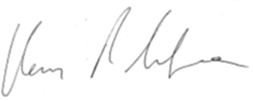

Signed:

Dated: 09/07/2024

Portfolio holder and elected Cabinet

For and on behalf of London Borough of Waltham Forest,

Annex A:
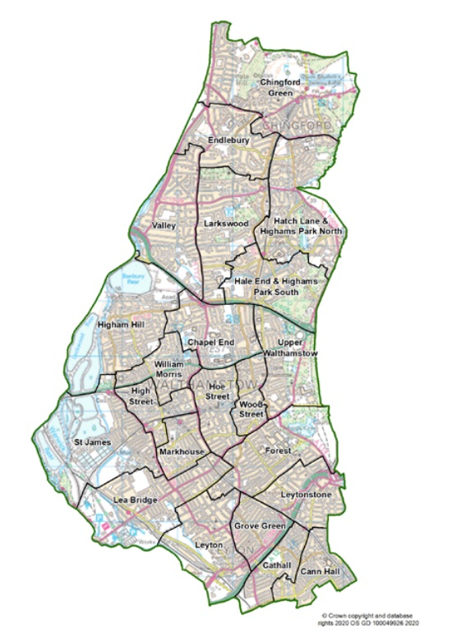

Annex B: HMOs to which this designation applies [subject to paragraphs 5a and 5d above]

A building or a part of a building meets the standard test if—

- It consists of one or more units of living accommodation not consisting of a self-contained flat or flats;
- The living accommodation is occupied by persons who do not form a single household;
- the living accommodation is occupied by those persons as their only or main residence or they are to be treated as so occupying it;
- Their occupation of the living accommodation constitutes the only use of that accommodation;
- Rents are payable or other consideration is to be provided in respect of at least one of those persons' occupation of the living accommodation; and
- Two or more of the households who occupy the living accommodation share one or more basic amenities or the living accommodation is lacking in one or more basic amenities.

A part of a building meets the self-contained flat test if—

(a) It consists of a self-contained flat; and
(b) Paragraphs (b) to (f) of standard test definition above apply (reading references to the living accommodation concerned as references to the flat).

A building or a part of a building meets the converted building test if—

- It is a converted building;
- It contains one or more units of living accommodation that do not consist of a self-contained flat or flats (whether or not it also contains any such flat or flats);
- The living accommodation is occupied by persons who do not form a single household;
- The living accommodation is occupied by those persons as their only or main residence or they are to be treated as so occupying it;
- Their occupation of the living accommodation constitutes the only use of that accommodation; and
- Rents are payable or other consideration is to be provided in respect of at least one of those persons' occupation of the living accommodation.

“Basic amenities” means—

(a) A toilet,
(b) Personal washing facilities, or
(c) Cooking facilities

“Converted building” means a building or part of a building consisting of living accommodation in which one or more units of such accommodation have been created since the building or part was constructed;

“Enactment” includes an enactment comprised in subordinate legislation (within the meaning of the Interpretation Act 1978 (c. 30);

“Self-contained flat” means a separate set of premises (whether or not on the same floor)—

- which forms part of a building;
- either the whole or a material part of which lies above or below some other part of the building; and
- in which all three basic amenities are available for the exclusive use of its occupants

HMO declarations

If a local housing authority are satisfied that a building or part of a building in their area meets either:

- the standard test; or
- the self-contained flat test; or
- the converted building test

they may serve a notice under this section (an “HMO declaration”) declaring the building or part to be a house in multiple occupation.

Annex C: Buildings which are not HMOs for purposes of this designation

In the following paragraphs “building” includes a part of a building.

Buildings controlled or managed by public sector bodies etc

A building where the person managing or having control of it is

- a local housing authority,
- a non-profit registered provider of social housing,
- a body which is registered as a social landlord under Part 1 of the Housing Act 1996,
- a police and crime commissioner,
- the Mayor's Office for Policing and Crime,
- a fire and rescue authority, or
- a health service body [within the meaning of section 9 of the National Health Service Act 2006].

“fire and rescue authority” means a fire and rescue authority under the Fire and Rescue Services Act 2004

A building—

- Which is social housing within the meaning of Part 2 of the Housing and Regeneration Act 2008, and
- Where the person managing or having control of it is a profit-making registered provider of social housing.]

Buildings controlled or managed by a co-operative society

A building where—

- The person managing or having control of it is a co-operative society whose rules are such as to secure that each of the conditions set out in sub-paragraph (2) is met, and
- No person who occupies premises in the building does so by virtue of an assured tenancy, a secure tenancy or a protected tenancy.

(2) The conditions are—
(a) That membership of the society is restricted to persons who are occupiers or prospective occupiers of buildings managed or controlled by the society,
(b) That all management decisions of the society are made by the members (or a specified quorum of members) at a general meeting which all members are entitled to, and invited to, attend,
(c) That each member has equal voting rights at such a meeting, and
(d) That, if a person occupies premises in the building and is not a member, that person is an occupier of the premises only as a result of sharing occupation of them with a member at the member's invitation.
(3) For the purposes of sub-paragraph (a) “co-operative society” means a body that—

(a) Is registered as a co-operative society under the 2014 Act or is a pre-commencement society (within the meaning of that Act) that meets the condition in section 2(2)(a)(i) of that Act, and
(b) Is neither—
(i) A non-profit registered provider of social housing, nor
(ii) Registered as a social landlord under Part 1 of the Housing Act 1996.
(4) In this paragraph—
- “the 2014 Act” means the Co-operative and Community Benefit Societies Act 2014;]
- “assured tenancy” has the same meaning as in Part 1 of the Housing Act 1988;
- “protected tenancy” has the same meaning as in the Rent Act 1977;
- “secure tenancy” has the same meaning as in Part 4 of the Housing Act 1985.]

Buildings regulated otherwise than under this Act

Any building whose occupation is regulated otherwise than by or under this Act and which is of a description specified for the purposes of this paragraph in regulations made by the appropriate national authority.

Buildings occupied by students

Any building—

- which is occupied solely or principally by persons who occupy it for the purpose of undertaking a full-time course of further or higher education at a specified educational establishment or at an educational establishment of a specified description, and
- where the person managing or having control of it is the educational establishment in question or a specified person or a person of a specified description.

(2) In sub-paragraph (a) “specified” means specified for the purposes of this paragraph in regulations made by the appropriate national authority.

(3) Sub-paragraph (4) applies in connection with any decision by the appropriate national authority as to whether to make, or revoke, any regulations specifying—
(a) A particular educational establishment, or
(b) A particular description of educational establishments.

(4) The appropriate national authority may have regard to the extent to which, in its opinion—

- the management by or on behalf of the establishment in question of any building or buildings occupied for connected educational purposes is in conformity with any code of practice for the time being approved under section 233 which appears to the authority to be relevant, or
- the management of such buildings by or on behalf of establishments of the description in question is in general in conformity with any such code of practice, as the case may be.

(5) In sub-paragraph (4) “ occupied for connected educational purposes ”, in relation to a building managed by or on behalf of an educational establishment, means occupied solely or principally by persons who occupy it for the purpose of undertaking a full-time course of further or higher education at the establishment.

Buildings occupied by owners

Any building which is occupied only by persons within the following paragraphs—

- one or more persons who have, whether in the whole or any part of it, either the freehold estate or a leasehold interest granted for a term of more than 21 years;
- any member of the household of such a person or persons;
- No more than such number of other persons as is specified for the purposes of this paragraph in regulations made by the appropriate national authority.
- This paragraph does not apply in the case of a converted block of flats to which section 257 applies, except for the purpose of determining the status of any flat in the block.

Buildings occupied by two persons

Any building which is occupied only by two persons who form two households.

Section 55 of the Act defines which Houses in Multiple Occupation are required to be licensed under the Act. See also The Licensing of Houses.in Multiple Occupation (Prescribed Descriptions) (England) Order 2005 (SI 2006/371)
Schedule 14 Housing Act 2004 describes the buildings that are not HMOs other than for the purpose of Part 1 [HHSRS]
Section 232 of the Act and paragraph 11 of SI 373/2006
For the definition of “persons not forming a single household” please see Section 258 Housing Act 2004
For the definition of “persons treated as occupying premises as only or main residence” please see Section 259 Housing Act 2004
For the definition of “persons not forming a single household” please see Section 258 Housing Act 2004
For the definition of “persons treated as occupying premises as only or main residence” please see Section 259 Housing Act 2004
The number of persons specified for the purposes of paragraph (c) under ‘Buildings Occupied by owners’ in The Licensing and Management of Houses in Multiple Occupation and Other Houses (Miscellaneous Provisions) (England) Regulations 2006 is two.

