Property and Asset Management

Waltham Forest Town Hall, Forest Road, London E17 4JF

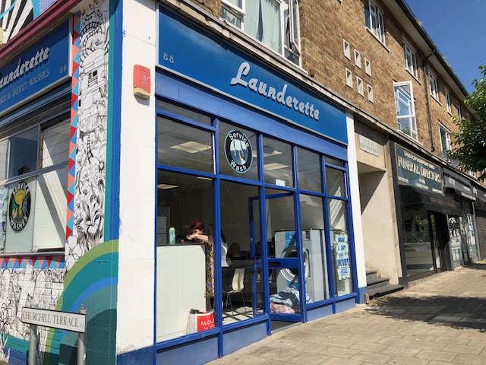

TO LET | LOCK-UP SHOP
 | 88 OLD CHURCH ROAD
 | CHINGFORD E4 8BX
LOCATION: | Access to the M11 and the North Circular Road.  British Rail nearby (Chingford Station).
DESCRIPTION: | Lock-up shop, reasonable condition with store / kitchen room and WC, rear access. Available immediately.
FLOOR AREA: | Net internal area approximately 775 sq ft (72 sqm)
TERMS: | Minimum lease of 3 years for Planning Use Class E.  Lease offered to Jan 2033, outside of security provisions of 1954 Landlord & Tenant Act  Catering (hot food) subject to planning requirements
RENT: | Offers in the region of £17,000 pa (exclusive)
RATES: | 01 April 2023: Rateable Value £13,750  Subject to small business rates relief – please make own enquiries with Council Business Rates Team
COSTS: | All legal costs will be borne by the new tenant (Costs TBC)
VIEWING: | By prior appointment with Property Services (Sunil Kumar)
 | Telephone 020 8496 8069 / 07989 195 279 or email: sunil.kumar@walthamforest.gov.uk
OFFERS: | To Sunil Kumar, Area Estate Manager.
 | Include:
- Details of your proposed use and length of lease required.
- Proof of identity i.e. a copy of passport / driving licence and a recent utility invoice for home address (no more than 3 months old)
- Last six months bank statements, together with mortgagees or landlords reference, two trade referees if applicable.

These particulars do not form part of any offer or contract. All statements contained in these particulars are made without responsibility of the vendor/agent/lessor and should not be relied upon as statements or representations of fact. Any intending purchasers/tenants must satisfy themselves by inspection or otherwise as to the correctness of each of the statements contained in these particulars. The vendor/agent/lessor does not give any warranty whatsoever in relation to the property.

